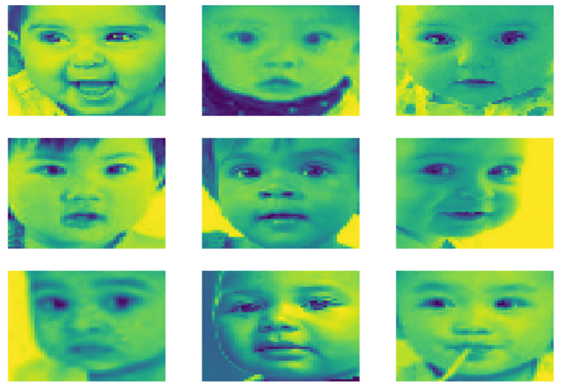

GENDER AND AGE CLASSIFICATION

JATiN RAHEJA, PRATHEEK SIDDALINGIAH NARENDRA, SHAOCHENG SHI, Emily Gonzalez

PROJECT DESCRIPTION AND GOALS

Age and gender pay a crucial role in modern social interactions, people usually tend to interact more with people close to their own age and of the same gender. This project deals with analyzing the facial contours to determine the age and gender of a person irrespective of ethnicity. We shall be implementing machine learning algorithms to properly identify the age and gender of the person from an image. We are employing logistic regression for it’s more accurate results. Ultimately the final goal of this project is to determine the gender and to as accurately as possible determine the age of a person

PROJECT DETAILS

In this project we are taking multiple images as data for training and testing the algorithm. We have taken 23704 images as data each image varies from age gender and ethnicity so that we may ge a more accurate result by using more diverse input. After implementing all the data, we will use the algorithm to determine the gender and age as accurately as possible.

DEVELOPED ALGORITHM AND TOOLS

With the goal being to determine the age and gender of a person we have used the machine learning algorithm logistic regression. We have used plotly and matplotlib libraries to gain figures of a very high quality in variable formats.

RESULT

After extensive implementation training and testing the data we achieved the following result

* For age estimation we achieved an accuracy of 47%
* For gender estimation we achieved an accuracy of 76.06%

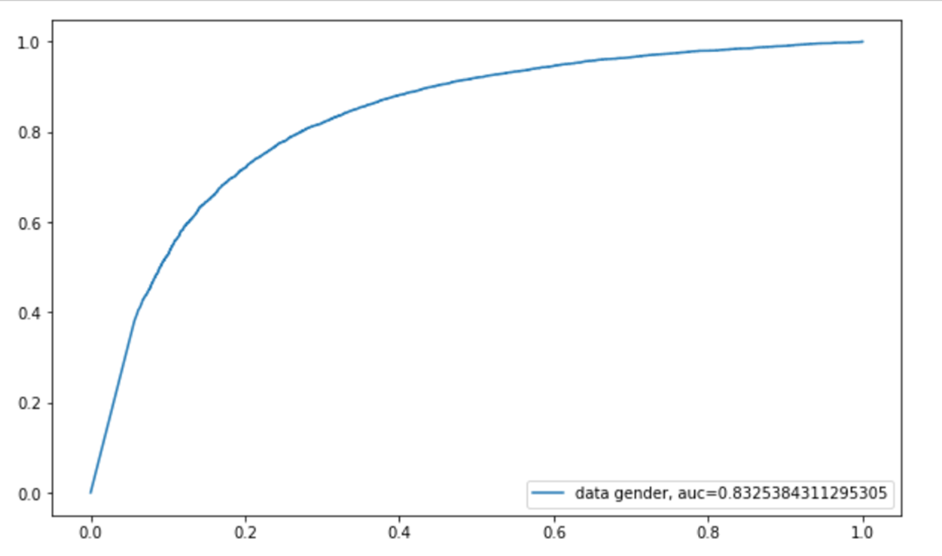

PROBLEMS

A few of the problems we have encountered in this project were related to limited memory resources, amount of data available for training and testing of data and accuracy of predicted age. As age recognition depend on facial analysis this may be hampered by scaring facial cosmetics, etc.

TEAM RESPNSEBILITIES

Jatin Raheja is the team leader responsible for coding, implementation and research Pratheek is responsible for debugging, coding and report preparation Shaocheng Shi is responsible for debugging and documentation Emily Gonzalez is responsible for slide preparation and debugging.